
EASTERN INTERNATIONAL UNIVERSITY

MIS 443
Business Data Management Q4
Assignment 02
Word Report

Lecturer: Dang Thai Doan

Name | IRN | Github Repository link
Phạm Thùy Trang | 2332300158 | https://github.com/TrangPham-25
Tăng Sở Hân | 2332300046 | https://github.com/hants1825-sys/MIS443_Ecommers-Dataset-
Lữ Anh Thư | 2332300138 | https://github.com/thulubbs23-cpu/MIS443_Group_Data_Minds_Ecommerce
Nguyễn Thị Ánh Tuyết | 2332300334 | https://github.com/tuyetnguyenthianhbbs23-collab/MIS-443

1. Introduction
This report documents the design, implementation, and querying of a relational e-commerce database developed as part of MIS 443 Assignment 2. Data Minds group selected the E-Commerce schema from SQL Practice Online and recreated it in PostgreSQL using pgAdmin 4.
The database models a simplified online retail environment in which customers place orders for products organised into categories. The project covers the full development cycle: schema analysis, table creation with integrity constraints, data preparation and loading, and the completion of thirty SQL practice questions ranging from basic retrieval to window functions and common table expressions (CTEs).
The primary objectives of this assignment were to interpret a relational schema, implement it correctly in PostgreSQL, ensure data integrity through primary and foreign keys, and demonstrate proficiency in writing analytical SQL queries that support business decision-making.

2. Selected Database Context
The E-Commerce schema represents the core operational data of a small-to-medium online retailer. It captures customer profiles, a product catalogue structured by category, customer orders, and the individual line items within each order.
From a business perspective, the schema supports typical analytical needs such as:
- Identifying high-value customers and assigning loyalty tiers based on total spend.
- Measuring product and category revenue performance.
- Tracking order fulfilment status (pending, shipped, delivered).
- Detecting products that have never been ordered.
- Ranking products by price within and across categories.
These capabilities align with common business intelligence requirements in retail operations, inventory planning, and customer relationship management.

3. Main Tables and Relationships
The database consists of five normalised tables. The design follows third normal form (3NF) to minimise redundancy while preserving referential integrity.

3.1 Table Overview
Table | Purpose | Key Columns
customers | Customer master data | customer_id (PK), first_name, last_name, email (UNIQUE), registration_date, city, country
categories | Product category catalogue | category_id (PK), category_name, description
products | Product master data | product_id (PK), product_name, category_id (FK), price, stock_quantity, created_date
orders | Customer order headers | order_id (PK), customer_id (FK), order_date, total_amount, status
order_items | Order line items | order_item_id (PK), order_id (FK), product_id (FK), quantity, unit_price

3.2 Relationships
The following one-to-many relationships are enforced through foreign-key constraints:
- customers → orders (one customer may place many orders).
- categories → products (one category contains many products).
- orders → order_items (one order contains many line items).
- products → order_items (one product may appear in many line items).
All foreign keys reference the corresponding primary keys and were created with explicit constraint names (for example, fk_order_customer and fk_product_category) to improve maintainability and error diagnostics.

3.3 Entity–Relationship Diagram
Figure 1 illustrates the complete entity–relationship structure of the E-Commerce database, including primary keys, foreign keys, and cardinalities.
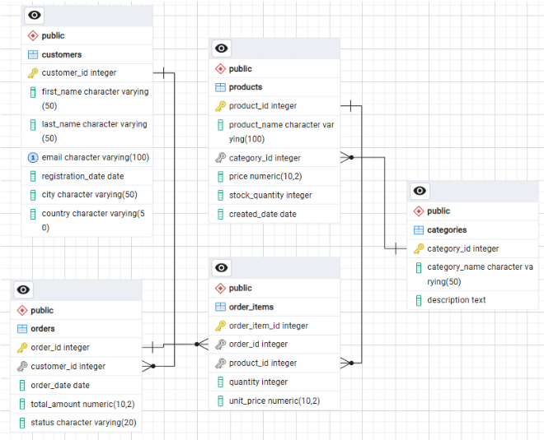
Figure 1. Entity–Relationship Diagram of the E-Commerce schema

4. Summary of Database Implementation
The database was implemented in PostgreSQL and managed through pgAdmin 4. The implementation followed a controlled sequence to respect foreign-key dependencies.

4.1 Structure
- 01_create_database.sql – Creates the ecommerce database.
- 02_create_tables_relationships.sql – Creates all five tables, primary keys, unique constraints, and foreign-key relationships.
- 03_insert_data.sql – Documents the data-loading procedure (CSV import via pgAdmin Import/Export).
- 04_questions.sql – Contains the complete set of thirty SQL solutions with question descriptions as comments.

4.2 Data Preparation
Five CSV files were prepared in the data folder, one for each table. Each file includes a header row with column names that match the database schema. Data volumes are modest but sufficient to exercise all thirty practice questions:
CSV File | Rows | Notes
customers.csv | 6 | Includes one customer without orders and one with a missing city value
categories.csv | 5 | Electronics, Clothing, Books, Home & Garden, Sports
products.csv | 8 | Covers all five categories; one product has never been ordered
orders.csv | 6 | Statuses: delivered, shipped, pending; all orders dated June 2023
order_items.csv | 9 | Line totals are consistent with the total_amount values stored in orders

4.3 Data-Loading Order
Tables were populated in dependency order to satisfy foreign-key constraints:
- customers and categories (independent parent tables)
- products (depends on categories)
- orders (depends on customers)
- order_items (depends on orders and products)

4.4 Integrity Verification
After loading, the following checks were performed:
- Primary-key uniqueness for every table.
- Foreign-key referential integrity (no orphan records).
- Consistency between order_items line totals and orders.total_amount.
- Presence of edge-case records required by specific questions (null city, unordered product, customer without orders).
All thirty questions associated with the E-Commerce schema on SQL Practice Online were completed and tested in pgAdmin. The solutions use PostgreSQL-compatible syntax and are stored in 04_questions.sql with each question description included as an SQL comment.

5. Summary of the 30 SQL Questions

5.1 Question Categories
Topic Area | Questions | Techniques Applied
Basic retrieval | 1–6 | SELECT, WHERE, ORDER BY, COUNT, AVG
Filtering & dates | 7–13 | Equality filters, BETWEEN, DISTINCT, missing value, date arithmetic
Joins | 14–16, 20 | INNER JOIN across two to five tables
Aggregation | 15, 17, 30 | GROUP BY, HAVING, SUM, revenue calculations
Subqueries | 18, 19, 24, 29 | NOT IN, correlated subqueries, scalar subqueries
Outer joins & set ops | 21–22 | LEFT JOIN, COALESCE, UNION ALL with labels
Window functions | 23, 26, 28 | RANK, NTILE, PARTITION BY
CTEs & analytics | 25, 27 | CASE tiering, WITH clauses for max-price-per-category

Core Data Retrieval & Filtering: The initial query block establishes foundational data extraction using basic SELECT statements, sorting (ORDER BY), and initial aggregation (COUNT, AVG) across questions 1–6, followed by precise equity filters, BETWEEN, DISTINCT, missing value, and date arithmetic across questions 7–13.

Aggregation, Joins & Set Operations: Intermediate queries scale complexity through multi-table INNER JOIN operations spanning two to five tables (Questions 14–16, 20), robust revenue calculations leveraging GROUP BY and HAVING (Questions 15, 17, 30), and outer join integrations utilizing LEFT JOIN, COALESCE, and labeled UNION ALL statements (Questions 21–22).

Advanced Subqueries & Analytics: Complex relational requirements are handled using NOT IN, scalar, and correlated subqueries (Questions 18, 19, 24, 29).

Advanced Window Functions & CTEs: Modern analytical techniques incorporate window functions such as RANK and PARTITION BY with quartile distribution via NTILE(4) (Questions 23, 26, 28), alongside conditional CASE tiering and WITH clauses for max-price-per-category computations (Questions 25, 27).

5.2 Representative Business Insights
Several queries produce results that map directly to business questions:
- Revenue & Category Performance: Queries isolate high-yield segments by identifying product categories exceeding specific revenue thresholds (Question 17) and ranking the top five revenue-generating products to guide inventory focus (Question 30).
- Customer Value Segmentation: Advanced queries segment the customer base by evaluating lifetime spend (Question 24), assigning loyalty tiers (Gold, Silver, Bronze) coupled with fulfillment status (Question 25), and distributing purchasers into behavioral quartiles using ranking functions (Question 26).

6. Selected Screenshots from pgAdmin
6.1. Create Database:
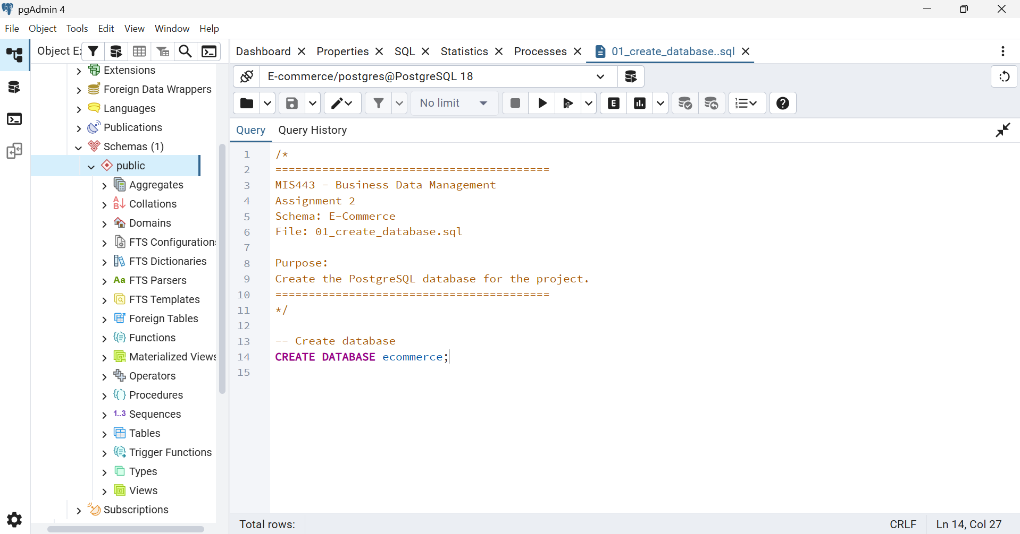

6.2. Create table relationship:
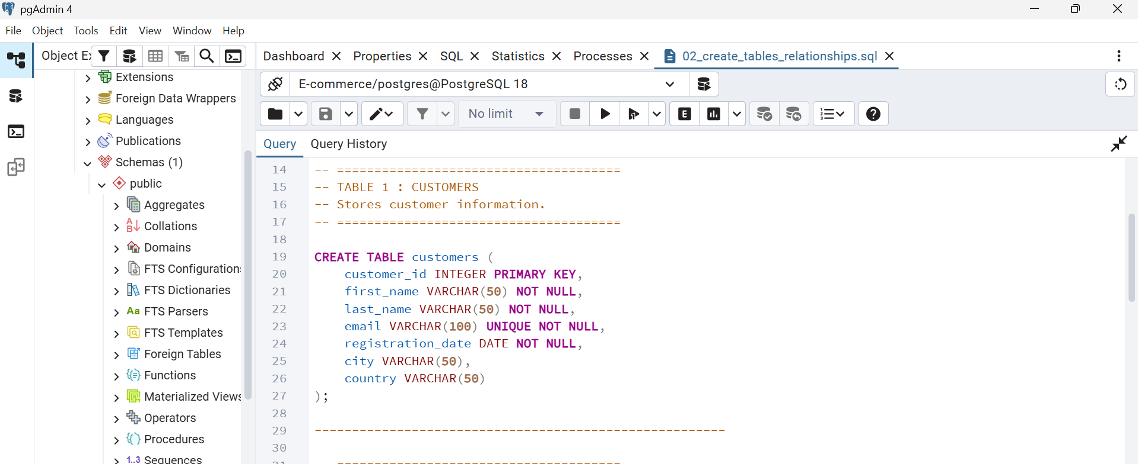

6.3. Insert data:
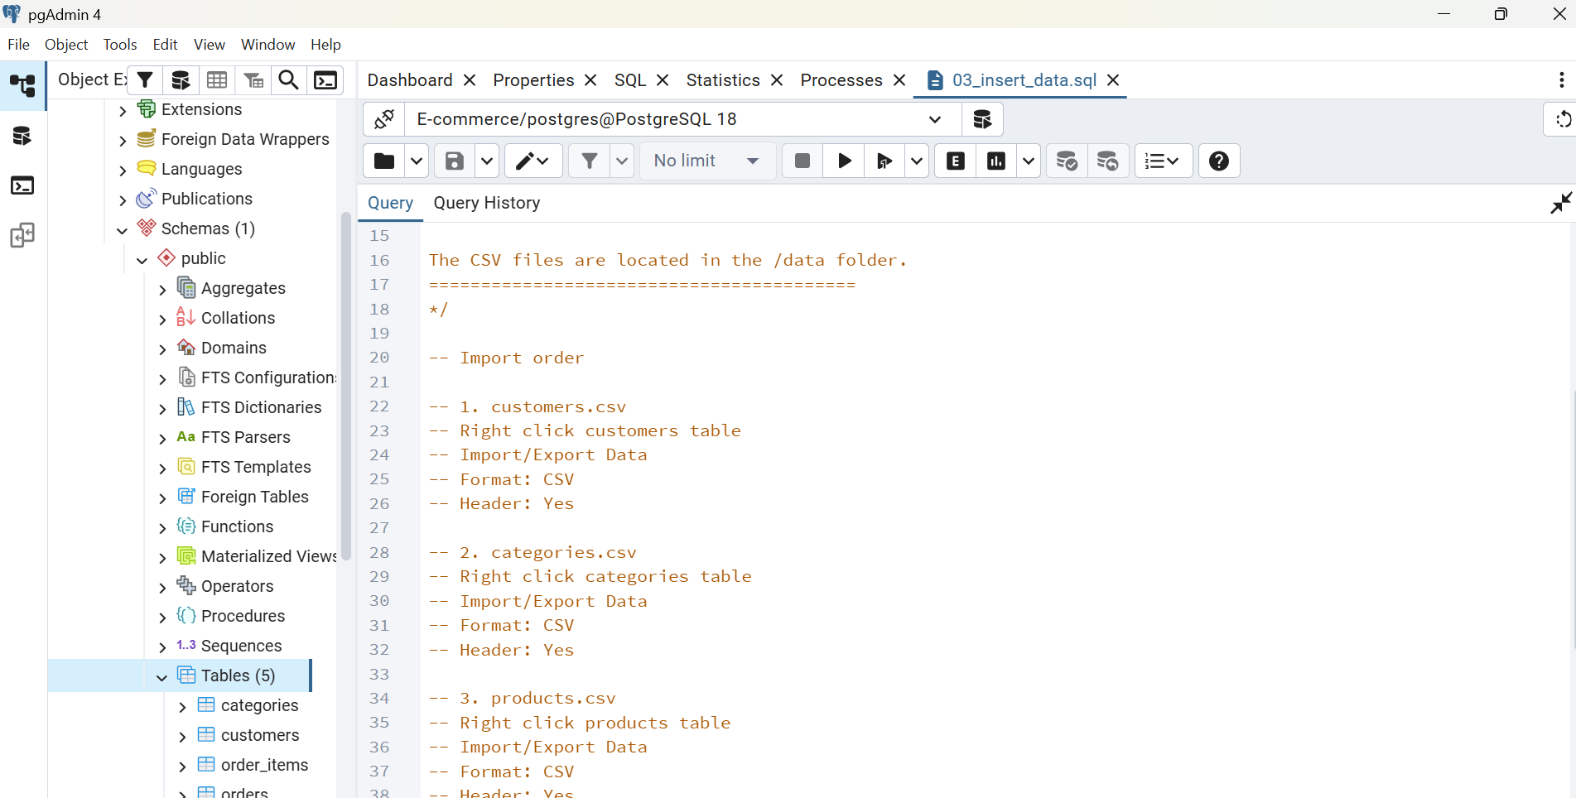

6.4. Questions:
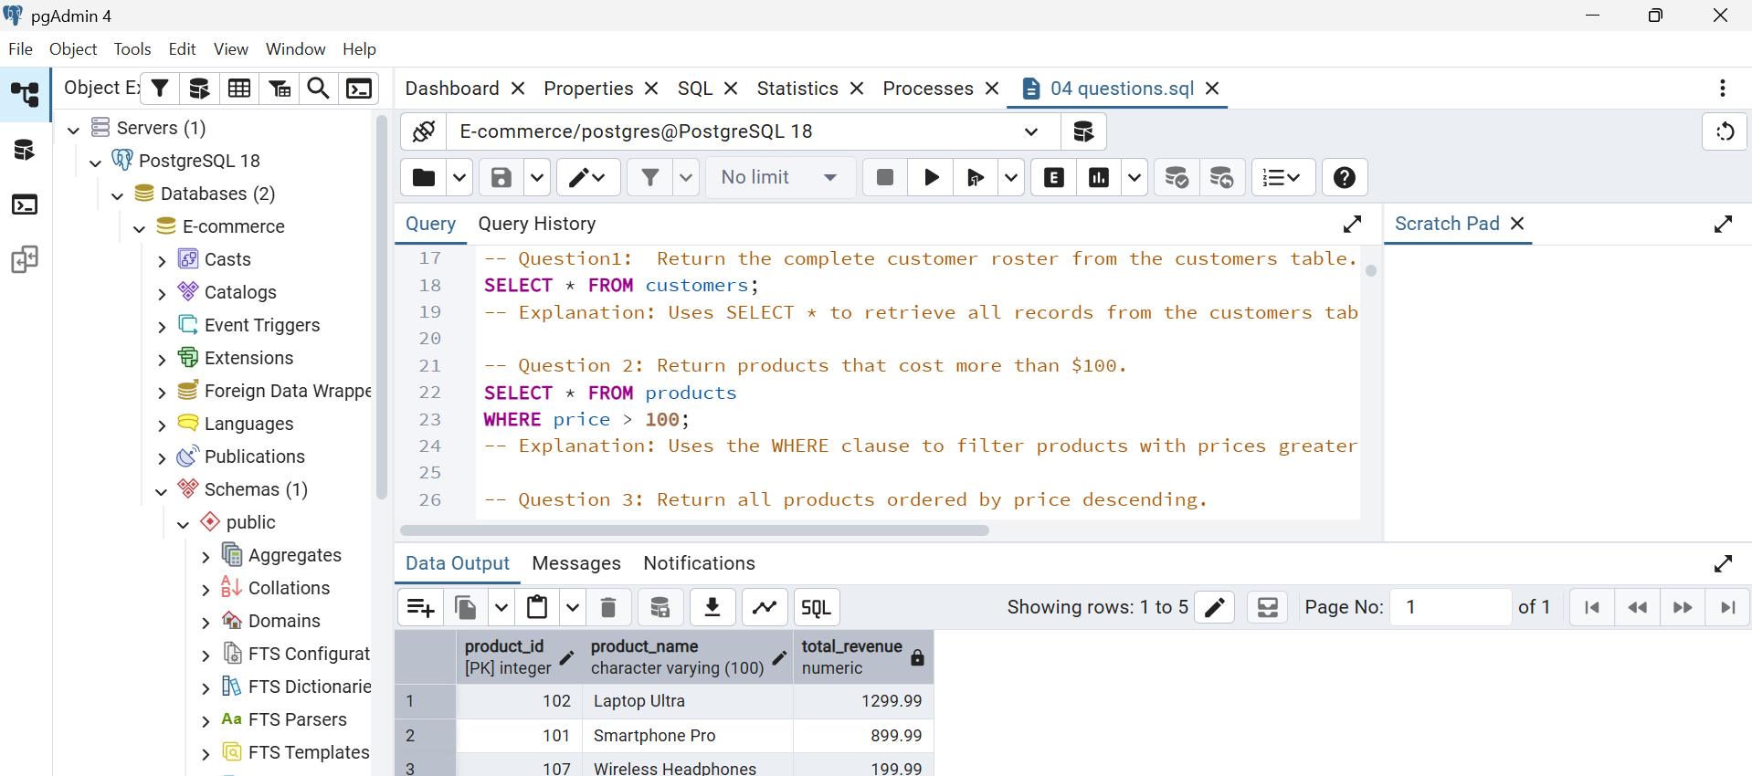

7. Challenges Encountered and Solutions Applied
During the database implementation, our group faced two main technical challenges:

7.1. Data Import Errors Due to Foreign Keys
Challenge: When importing CSV files into pgAdmin, we received foreign key error messages. For instance, importing order_items before orders failed because the referenced order IDs did not exist yet.
Solution: We fixed this by importing data in the correct sequence: parent tables with primary keys (like customers and orders) were filled first, followed by dependent child tables (like order_items).

7. 2. Complex Multi-Table Joins
Challenge: Questions requiring data from 3 or 4 tables (e.g., connecting customers, orders, and products) caused duplicate rows and wrong total sums when using simple JOINs.
Solution: We carefully chose the right join types (LEFT JOIN vs. INNER JOIN), correctly grouped the data using GROUP BY, and double-checked our results with SQL Practice Online.

8. Responsibilities and Contributions of Each Member
Member | Primary Responsibilities
Phạm Thùy Trang | Compiled and finalized the Word report, integrated system screenshots, and reviewed the report layout.
Tăng Sở Hân | Written and formatted the Word report, documented SQL query descriptions, and summarized project findings.
Lữ Anh Thư | Co-authored the final project Word report, structured document sections, and summarized database implementation.
Nguyễn Thị Ánh Tuyết | Executed database operations in pgAdmin 4, created database tables/relationships, imported CSV data, and tested SQL scripts.

9. Conclusion
This project successfully delivered a fully functional PostgreSQL implementation of the E-Commerce schema, complete with referential integrity constraints, a coherent sample dataset, and tested solutions to all thirty associated SQL practice questions.
Through the exercise the group strengthened practical skills in relational modelling, constraint design, data preparation, and analytical SQL. The combination of joins, aggregations, subqueries, window functions, and CTEs covers the core techniques required for business data analysis in a relational environment.
The complete project includes SQL scripts, CSV data files, the entity–relationship diagram, and this report is reproducible from the submitted package and has been published in each member’s personal GitHub repository. The work demonstrates both technical competence and effective team collaboration.

